**LABCYCLE**

**Submitted By,**

**Ananya B**

**MCA S1**

**Roll No: 113**

**LABCYCLE 1 QUESTION 1**

**AIM:** To Model a simple HTML file to demonstrate the use of different tags.

**PROGRAM CODE:**

CO1-Q1.html

|  |
| --- |
| <body>  <nav class="menu">  <ul>  <li><a href="page0.html">Home</a></li>  <li><a href="page2.html">About</a></li>  <li><a href="page1.html">Contact</a></li>  <li><a href="page3.html">Qualifications</a></li>  </ul>  </nav>  <marquee>  <font color = "magenta">  <h1>MY WEBPAGE!!!!!!!!</H1><BR> </marquee>  <h2>  <font color = "red">  <i>Hellooo All... I am ANANYA ...Welcome to my webpage....  I am a B.C.A graduate and now doing M.C.A in TKMCE.MY aim is to become a good teacher..After all live the rest of my life as a good human being.  And I come from Chengannur in Alappuzha District.<br>  For viewing my contact details,please click on this<a href ="page1.html">CONTACT!!</a><br>  I completed my graduation in B.C.A from <a href ="http://casperissery.ihrd.ac.in/">College of Applied Science Perissery,Chengannur.</a><br>  And now i am doing my post graduation in MCA in <a href ="https://tkmce.ac.in/">  TKM College of Engineering,Kollam.</a> <br>  I have done my graduation under the <a href ="https://www.keralauniversity.ac.in/">University of Kerala.</a><br>And all my educational qualifications are updated,for seeing that just click on this<a href ="page3.html">Qualification..</a><br>  Also...My strength ,my everything is my family..For knowing more about me and my family,just click on this link<a href="page2.html">Family....!</a>  </i>  <br>  </h2>  <marquee>  <font color = "green">  <h2><i>Thanks For Visiting My webpage</i> </h2></marquee>  </body>  </html> |

**RESULT**

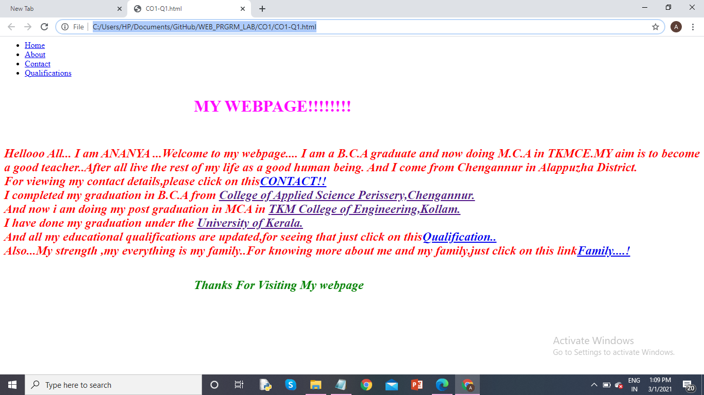

**LABCYCLE 1 QUESTION 2**

**AIM:** To Create a HTML file to link to different HTML page which contains images, tables, and also link within a page.

**PROGRAM CODE:**

|  |  |
| --- | --- |
| Page0.html | **<html>**  **<style>**  **body {**  **background-image: url('pretty.jpg');**  **}**  **</style>**  **<title> ANANYA B </title>**  **<body>**  **<nav class="menu">**  **<ul>**  **<li><a href="page0.html">Home</a></li>**  **<li><a href="page2.html">About</a></li>**  **<li><a href="page1.html">Contact</a></li>**  **<li><a href="page3.html">Qualifications</a></li>**  **</ul>**  **</nav>**  **<marquee>**  **<font color = "magenta">**  **<h1>MY WEBPAGE!!!!!!!!</H1><BR> </marquee>**  **<h2>**  **<font color = "red">**  **<i>Hellooo All... I am ANANYA ...Welcome to my webpage....**  **I am a B.C.A graduate and now doing M.C.A in TKMCE.MY aim is to become a good teacher..After all live the rest of my life as a good human being.**  **And I come from Chengannur in Alappuzha District.<br>**  **For viewing my contact details,please click on this<a href ="page1.html">CONTACT!!</a><br>**  **I completed my graduation in B.C.A from <a href ="http://casperissery.ihrd.ac.in/">College of Applied Science Perissery,Chengannur.</a><br>**  **And now i am doing my post graduation in MCA in <a href ="https://tkmce.ac.in/">**  **TKM College of Engineering,Kollam.</a> <br>**  **I have done my graduation under the <a href ="https://www.keralauniversity.ac.in/">University of Kerala.</a><br>And all my educational qualifications are updated,for seeing that just click on this<a href ="page3.html">Qualification..</a><br>**  **Also...My strength ,my everything is my family..For knowing more about me and my family,just click on this link<a href="page2.html">Family....!</a>**  **</i>**  **<br>**  **</h2>**  **<marquee>**  **<font color = "green">**  **<h2><i>Thanks For Visiting My webpage</i> </h2></marquee>**  **</body>**  **</html>** |
| Page1.html | **<html>**  **<style>**  **body {**  **background-image: url('wp.jpg');**  **}**  **</style>**  **<body>**  **<center>**  **<h2><font color="blue"> <i>Address & Contact </i></h2> <br>**  **<FONT FACE="Cooper" COLOR ="RED">**  **</b>**  **<I>**  **<h3> AKHIL NIVAS</H3>**  **<FONT FACE="Cooper" COLOR ="RED">**  **<h3> CHERIYANAD P.O</H3>**  **<font face="Cooper" color ="red">**  **<H3> CHENGANNUR</H3>**  **<FONT FACE="Cooper" COLOR ="RED">**  **<H3>ALAPPUZHA</H3>**  **<font face="Cooper" color ="red">**  **<H3>KERALA</H3>**  **<FONT FACE="Cooper" COLOR ="RED">**  **<h3>INDIA</h3>**  **<FONT FACE="Cooper" COLOR ="red">**  **<H3>PIN:689511</H3>**  **<FONT FACE="Cooper" COLOR ="red">**  **<h3>MOB:9846359103</H3>**  **<FONT FACE="Cooper" COLOR ="red">**  **<br></center>**  **<b>**  **<em> <h2><font color="blue"><marquee>Thanks for Visiting My Webpage....</marquee>**  **</b></h2></em>**  **</body>**  **</html>** |
| Page2.html | **<html>**  **<style>**  **body {**  **background-image: url('download.jpg');**  **}**  **</style>**  **<body>**  **<p style="text-align:center;">**  **<font color="green">**  **<h1>My Family..My World...</h1><br>**  **<FONT FACE="Cooper" COLOR ="blue">**  **<center>**  **<b>**  **<h2>Father: Muralidharan Nair G<br>**  **Mother: Bindhu.S<br>**  **Brother: Akhil Nair.M <br>**  **And Me.....**  **<h2></b><br></p>**  **</center><br>**  **<I><ol> <font color="blue">**  **<h2>**  **<li> <b>MY HOBBIES</b></LI></Ol></I>**  **<ul type ="bullet">**  **<li>Hearing music</li>**  **<li>Cooking</li>**  **<li>Surfing on internet</li>**  **<li>watching dance videos</li></h2>**  **</ul>**  **<b>**  **<em> <font color="green"><marquee>Thanks for Visiting My Webpage....</marquee>**  **</b></em>**  **</body></html>** |
| Page3.html | **<html>**  **<style>**  **body {**  **background-image: url('ab.jpg');**  **}**  **</style>**  **<body>**  **<center>**  **<TABLE BORDER ="3">**  **<MARQUEE>**  **<CAPTION><u><b> EDUCATIONAL QUALIFICATIONS </b></u></CAPTION>**  **</MARQUEE>**  **<TR >**  **<th> NO </TH>**  **<TH>QUALIFICATION</TH>**  **<TH>YEAR OF PASSING</TH>**  **<TH>PERCENTAGE</TH>**  **</TR>**  **<TR ><TH>1</TH>**  **<TD height=100px,width=200px>BCA</TD>**  **<TD>2020</TD>**  **<TD>81%</TD>**  **</TR>**  **<TR ><TH>2</TH>**  **<TD height=100px,width=200px>PLUS-TWO</TD>**  **<TD>2017</TD>**  **<TD>90%</TD>**  **</TR>**  **<TR >**  **<TH>3</TH>**  **<TD height=100px,width=200px> 1O-TH</TD>**  **<TD>2015</TD>**  **<TD>80</TD>**  **</TR>**  **</Table>**  **<br>**  **</center>**  **<b>**  **<em><h2> <font color="blue"><marquee>Thanks for Visiting My Webpage....</marquee>**  **</b></h2></em>**  **</body>**  **</html>** |

**RESULT**

Page0.html:

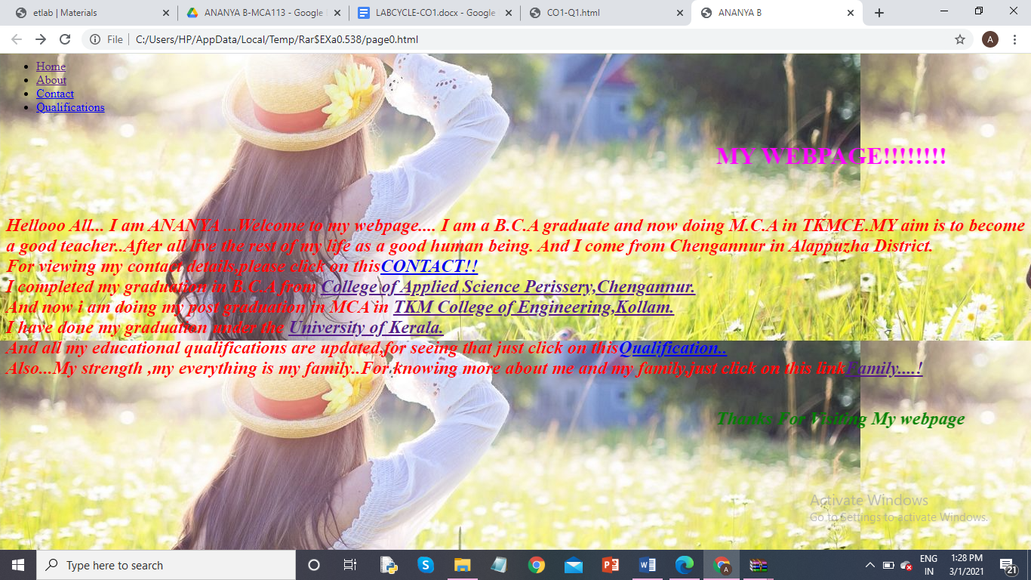

Page1.html:

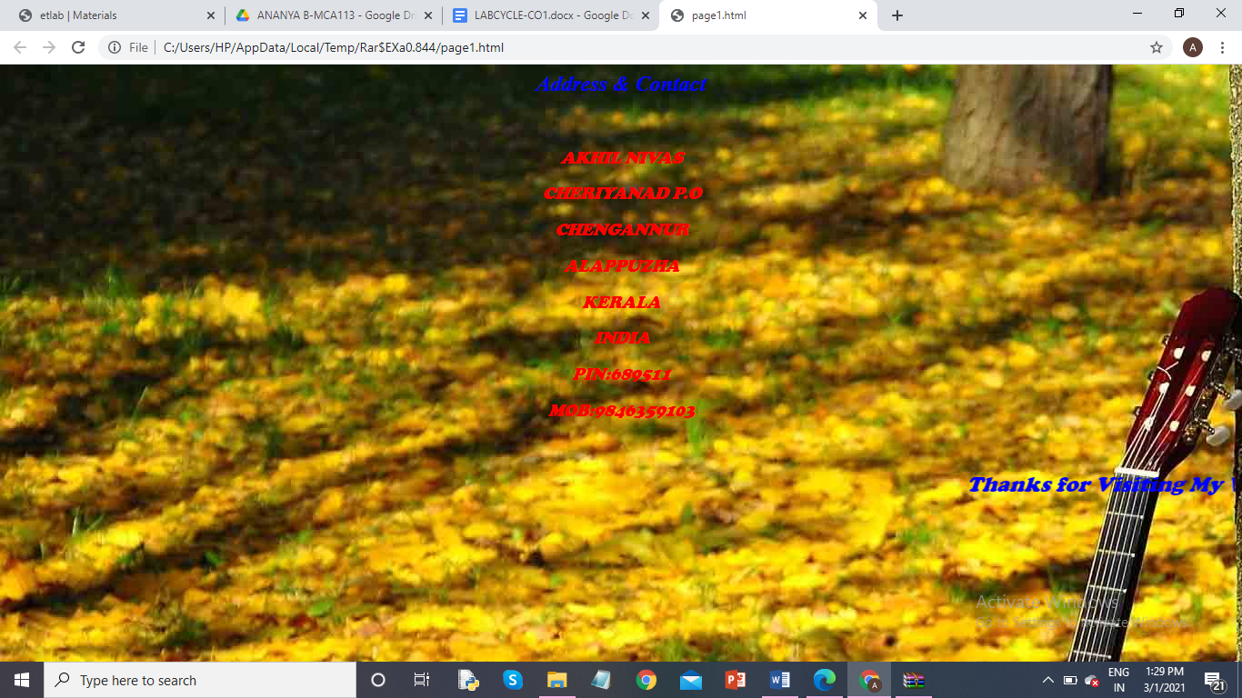

Page2.html:

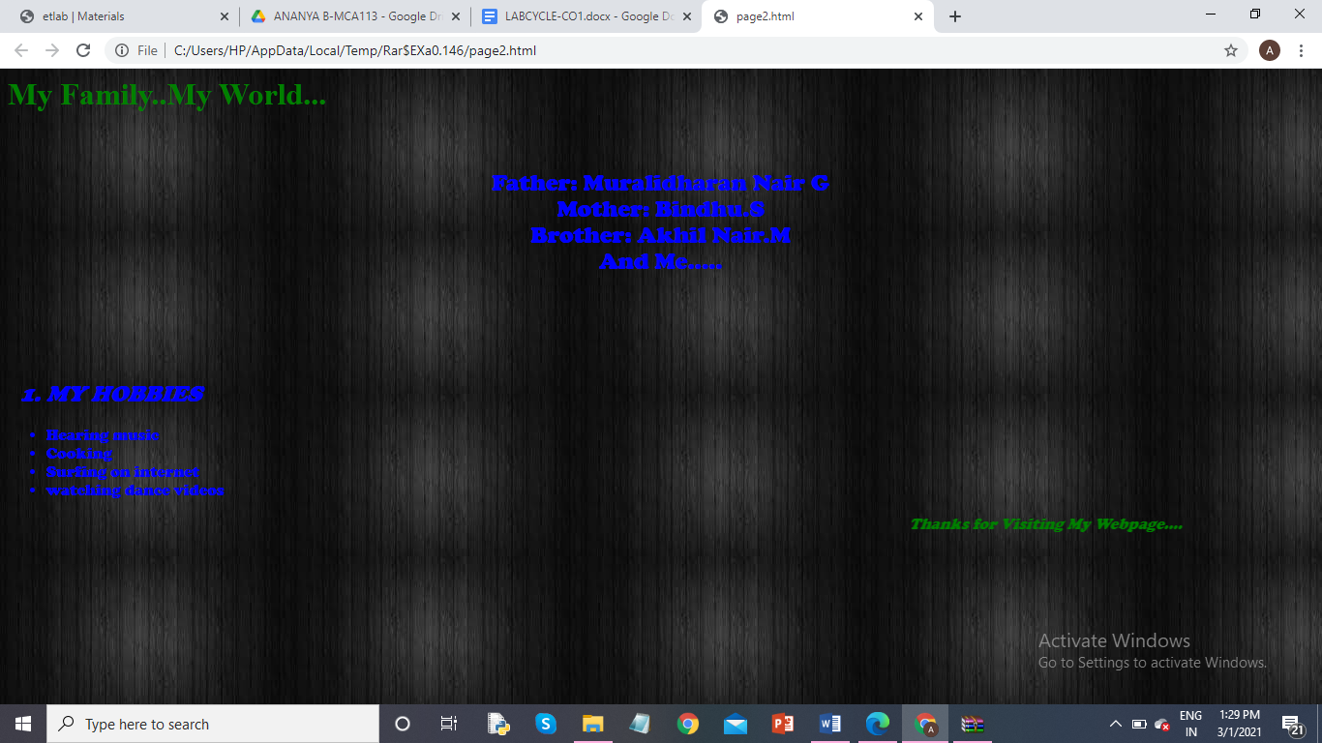

Page3.html:

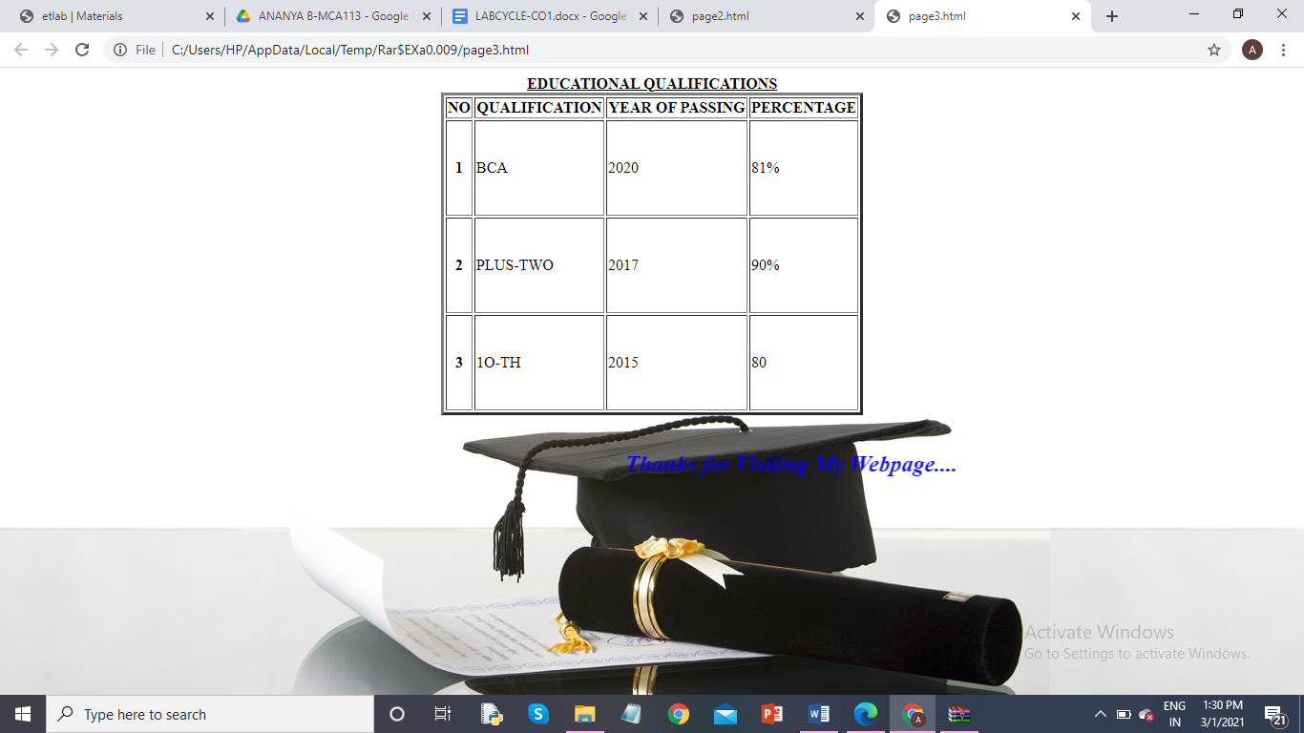

**LABCYCLE 1 QUESTION 3**

**AIM:** To Create a HTML page with different types of frames such as floating frame, navigation frame & mixed frame.

**PROGRAM CODE:**

|  |  |  |  |  |  |  |  |  |  |  |  |  |  |  |  |  |  |  |  |  |  |  |  |  |  |  |  |  |  |  |  |  |  |  |  |  |  |  |  |  |  |  |  |  |  |  |  |  |  |  |  |  |  |  |  |  |  |  |  |  |  |  |  |  |  |  |  |  |  |  |  |  |  |  |  |  |  |  |  |  |  |  |  |  |  |  |  |  |  |  |  |  |  |  |  |  |  |  |  |  |  |  |  |  |  |  |  |  |  |  |  |  |  |  |  |  |  |
| --- | --- | --- | --- | --- | --- | --- | --- | --- | --- | --- | --- | --- | --- | --- | --- | --- | --- | --- | --- | --- | --- | --- | --- | --- | --- | --- | --- | --- | --- | --- | --- | --- | --- | --- | --- | --- | --- | --- | --- | --- | --- | --- | --- | --- | --- | --- | --- | --- | --- | --- | --- | --- | --- | --- | --- | --- | --- | --- | --- | --- | --- | --- | --- | --- | --- | --- | --- | --- | --- | --- | --- | --- | --- | --- | --- | --- | --- | --- | --- | --- | --- | --- | --- | --- | --- | --- | --- | --- | --- | --- | --- | --- | --- | --- | --- | --- | --- | --- | --- | --- | --- | --- | --- | --- | --- | --- | --- | --- | --- | --- | --- | --- | --- | --- | --- | --- | --- |
| Page0.html | |  | | --- | |  | |  |  | | |  | | --- | | <html> | |  | <style> | |  | body { | |  | background-image: url('pretty.jpg'); | |  | } | |  | </style> | |  | <title> ANANYA B </title> | |  | <body> | |  | <nav class="menu"> | |  | <ul> | |  | <li><a href="page0.html">Home</a></li> | |  | <li><a href="page2.html">About</a></li> | |  | <li><a href="page1.html">Contact</a></li> | |  | <li><a href="page3.html">Qualifications</a></li> | |  | </ul> | |  | </nav> | |  |  | |  |  | |  | <marquee> | |  | <font color = "magenta"> | |  | <h1>MY WEBPAGE!!!!!!!!</H1><BR> </marquee> | |  | <h2> | |  | <font color = "red"> | |  | <i>Hellooo All... I am ANANYA ...Welcome to my webpage.... | |  | I am a B.C.A graduate and now doing M.C.A in TKMCE.MY aim is to become a good teacher..After all live the rest of my life as a good human being. | |  | And I come from Chengannur in Alappuzha District.<br> | |  | For viewing my contact details,please click on this<a href ="page1.html">CONTACT!!</a><br> | |  | I completed my graduation in B.C.A from <a href ="<http://casperissery.ihrd.ac.in/>">College of Applied Science Perissery,Chengannur.</a><br> | |  | And now i am doing my post graduation in MCA in <a href ="<https://tkmce.ac.in/>"> | |  | TKM College of Engineering,Kollam.</a> <br> | |  |  | |  | I have done my graduation under the <a href ="<https://www.keralauniversity.ac.in/>">University of Kerala.</a><br>And all my educational qualifications are updated,for seeing that just click on this<a href ="page3.html">Qualification..</a><br> | |  | Also...My strength ,my everything is my family..For knowing more about me and my family,just click on this link<a href="page2.html">Family....!</a> | |  | </i> | |  | <br> | |  |  | |  | </h2> | |  | <marquee> | |  | <font color = "green"> | |  | <h2><i>Thanks For Visiting My webpage</i> </h2></marquee> | |  | </body> | |  | </html> | |  | |  |  | |  |  | |  |  | |  |  | |  |  | |  |  | |  |  | |  |  | |  |  | |  |  | |  |  | |  |  | |  |  | |  |  | |
| Page1.html | |  | | --- | | <html> | |  | <title> ANANYA B </title> | |  | <style> | |  | body { | |  | background-image: url('wp.jpg'); | |  | } | |  | </style> | |  | <body> | |  | <center> | |  | <h2><font color="blue"> <i>Address & Contact </i></h2> <br> | |  | <FONT FACE="Cooper" COLOR ="RED"> | |  | </b> | |  | <I> | |  | <h3> AKHIL NIVAS</H3> | |  | <FONT FACE="Cooper" COLOR ="RED"> | |  | <h3> CHERIYANAD P.O</H3> | |  | <font face="Cooper" color ="red"> | |  | <H3> CHENGANNUR</H3> | |  | <FONT FACE="Cooper" COLOR ="RED"> | |  | <H3>ALAPPUZHA</H3> | |  | <font face="Cooper" color ="red"> | |  | <H3>KERALA</H3> | |  | <FONT FACE="Cooper" COLOR ="RED"> | |  | <h3>INDIA</h3> | |  | <FONT FACE="Cooper" COLOR ="red"> | |  | <H3>PIN:689511</H3> | |  | <FONT FACE="Cooper" COLOR ="red"> | |  | <h3>MOB:9846359103</H3> | |  | <FONT FACE="Cooper" COLOR ="red"> | |  | <br></center> | |  | <b> | |  | <em> <h2><font color="blue"><marquee>Thanks for Visiting My Webpage....</marquee> | |  | </b></h2></em> | |  | </body> | |  | </html> | |
| Page2.html | |  | | --- | | <html> | |  | <title> ANANYA B </title> | |  | <style> | |  | body { | |  | background-image: url('download.jpg'); | |  | } | |  | </style> | |  | <body> | |  | <p style="text-align:center;"> | |  | <font color="green"> | |  | <h1>My Family..My World...</h1><br> | |  | <FONT FACE="Cooper" COLOR ="blue"> | |  | <center> | |  | <b> | |  | <h2>Father: Muralidharan Nair G<br> | |  | Mother: Bindhu.S<br> | |  | Brother: Akhil Nair.M <br> | |  | And Me..... | |  | <h2></b><br></p> | |  |  | |  | </center><br> | |  | <I><ol> <font color="blue"> | |  | <h2> | |  | <li> <b>MY HOBBIES</b></LI></Ol></I> | |  |  | |  | <ul type ="bullet"> | |  | <li>Hearing music</li> | |  | <li>Cooking</li> | |  | <li>Surfing on internet</li> | |  | <li>watching dance videos</li></h2> | |  | </ul> | |  | <b> | |  | <em> <font color="green"><marquee>Thanks for Visiting My Webpage....</marquee> | |  | </b></em> | |  | </body></html> | |
| Page3.html | |  | | --- | | <html> | |  | <title> ANANYA B </title> | |  | <style> | |  | body { | |  | background-image: url('ab.jpg'); | |  | } | |  | </style> | |  | <body> | |  | <center> | |  | <TABLE BORDER ="3"> | |  | <MARQUEE> | |  | <CAPTION><u><b> EDUCATIONAL QUALIFICATIONS </b></u></CAPTION> | |  | </MARQUEE> | |  | <TR > | |  | <th> NO </TH> | |  | <TH>QUALIFICATION</TH> | |  | <TH>YEAR OF PASSING</TH> | |  | <TH>PERCENTAGE</TH> | |  | </TR> | |  | <TR ><TH>1</TH> | |  | <TD height=100px,width=200px>BCA</TD> | |  | <TD>2020</TD> | |  | <TD>81%</TD> | |  | </TR> | |  | <TR ><TH>2</TH> | |  | <TD height=100px,width=200px>PLUS-TWO</TD> | |  | <TD>2017</TD> | |  | <TD>90%</TD> | |  | </TR> | |  | <TR > | |  | <TH>3</TH> | |  | <TD height=100px,width=200px> 1O-TH</TD> | |  | <TD>2015</TD> | |  | <TD>80</TD> | |  | </TR> | |  | </Table> | |  | <br> | |  | </center> | |  | <b> | |  | <em><h2> <font color="blue"><marquee>Thanks for Visiting My Webpage....</marquee> | |  | </b></h2></em> | |  | </body> | |  | </html> | |
| floatingframe.html | |  | | --- | | <!DOCTYPE html> | |  | <html> | |  |  | |  | <head> | |  | <title>HTML Iframes</title> | |  | FLOATING FRAMES | |  | </head> | |  |  | |  | <body> | |  | <p>Microsoft...</p> | |  |  | |  | <iframe src = "msft.jpg" width = "500" height = "400"> | |  | Sorry your browser does not support inline frames. | |  | </iframe> | |  |  | |  | <p>Microsoft Corporation is an American multinational technology company with headquarters in Redmond, Washington. | |  | It develops, manufactures, licenses, supports, and sells computer software, consumer electronics, personal computers, and related services</p> | |  | </body> | |  |  | |  | </html> | |
| mixedframe.html | |  | | --- | | <html> | |  | <frameset rows="25%,75%"> | |  | <frame src="page1.html"> | |  | <frameset cols="50%,*"> | |  | <frame src="page2.html"> | |  | <frame src="page3.html"> | |  | </frameset> | |  |  | |  | </frameset> | |  |  | |  | </html> | |
| menu.html | |  | | --- | | <!DOCTYPE html> | |  | <html> | |  |  | |  | <body bgcolor = "yellow"> | |  | <a href = "page0.html" target = "main_page">Homepage</a> | |  | <br /> | |  |  | |  | <br /> | |  | <a href = "mixedfrme.html" target = "main_page">Click to see mixed frame</a> | |  | <br /> | |  | </body> | |  |  | |  | </html> | |
| co1-q3.html | |  | | --- | | <!DOCTYPE html> | |  | <html> | |  |  | |  | <head> | |  | <title>HTML Target Frames</title> | |  | </head> | |  |  | |  | <frameset cols = "200, *"> | |  | <frame src = "menu.html" name = "menu_page" > | |  | <frame src = "floatingframe.html" name = "floating_frame" > | |  |  | |  | <noframes> | |  | <body>Your browser does not support frames.</body> | |  | </noframes> | |  | </frameset> | |  |  | |  | </html> | |

**RESULT**

floatingframe.html

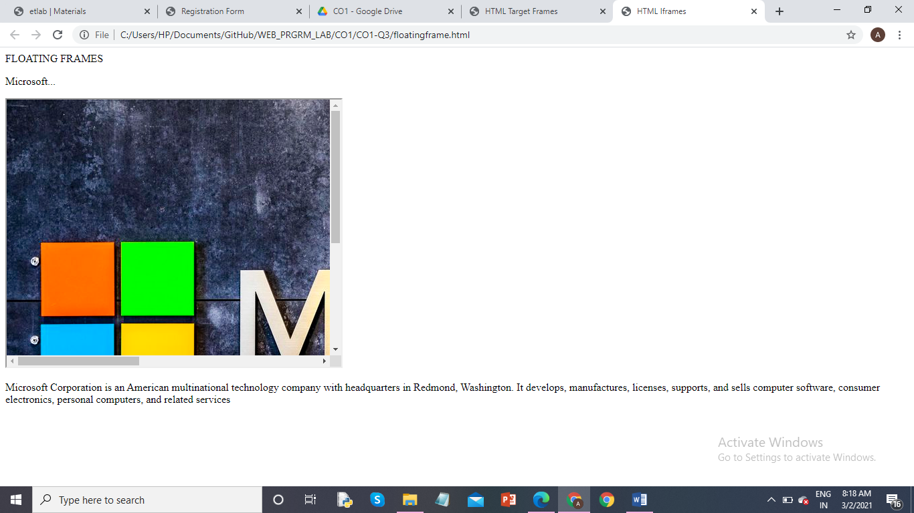

mixedframe.html

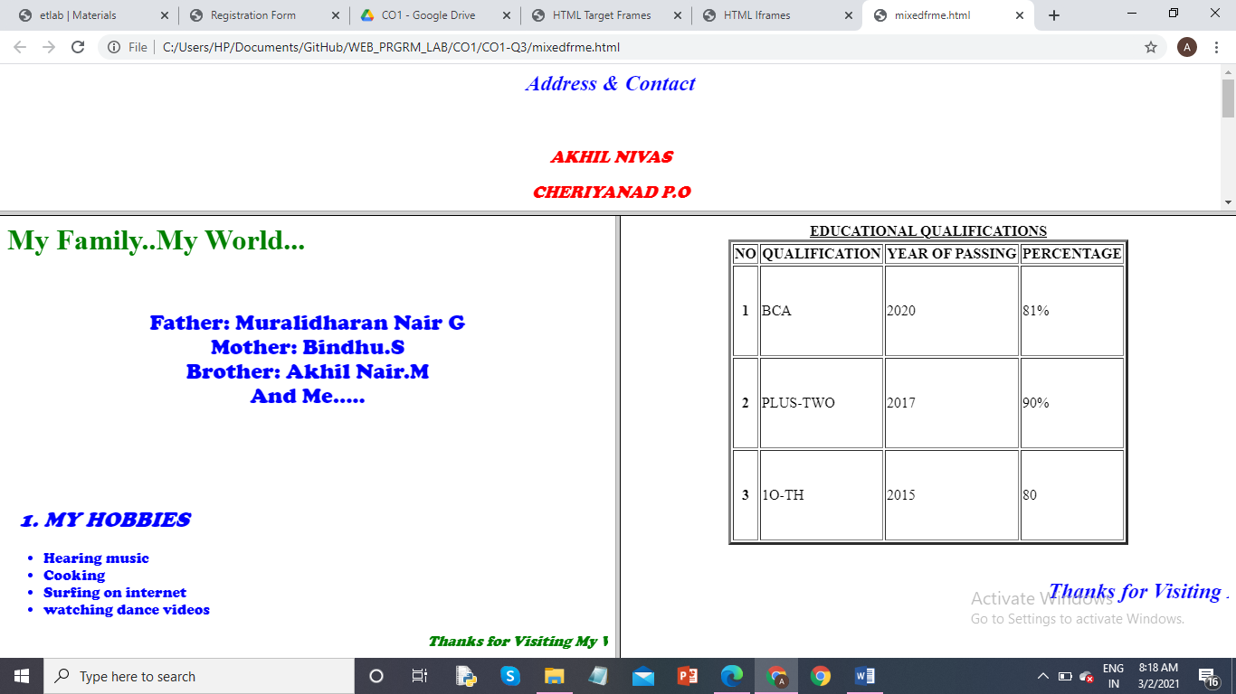

menu.html

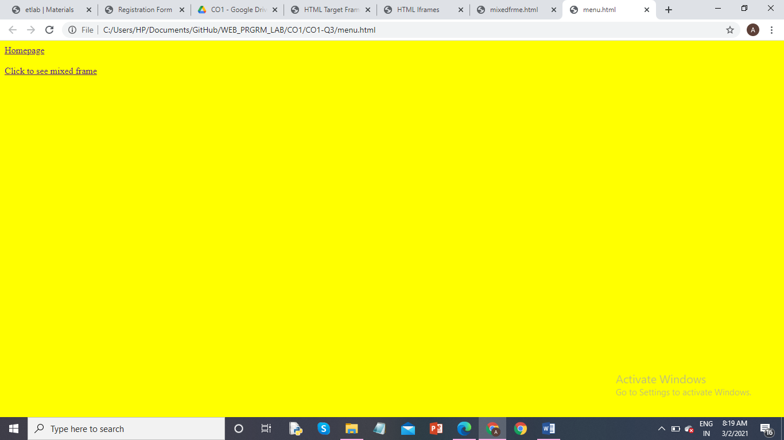

co1-q3.html

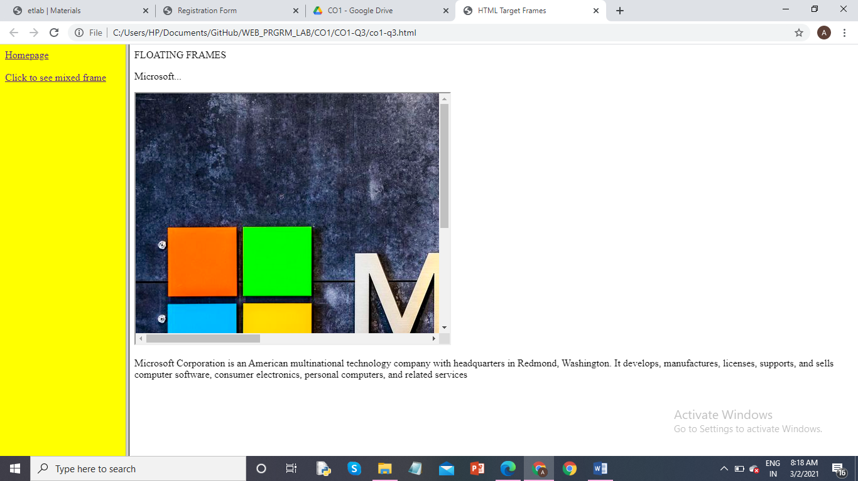

**LABCYCLE 1 QUESTION 4**

**AIM:** To Analyze CSS by applying the different styles using inline, external & internal style sheets in a HTML file

**PROGRAM CODE:**

|  |  |
| --- | --- |
| CO1-Q4.html | <!DOCTYPE html>  <html>  <head>  <!-- Background set by including external css -->  <link rel="stylesheet" href="mystyle.css">  <style>  h2 {  color:maroon;/*Internal css*/  margin-left:40px;  }  </style>  </head>  <body>  <!-- Inline css -->  <h1 style="color:blue;text-align:center;">INLINE CSS</h1>  <h3 style="color:yellow;text-align:center;">INLINE CSS</h3>  <h2>Internal CSS</h2>  </body>  </html> |

|  |  |
| --- | --- |
| Mystyle.css | body {  background-color: lightblue;  }  h1 {  color: navy;  margin-left: 20px;  } |

**RESULT:**

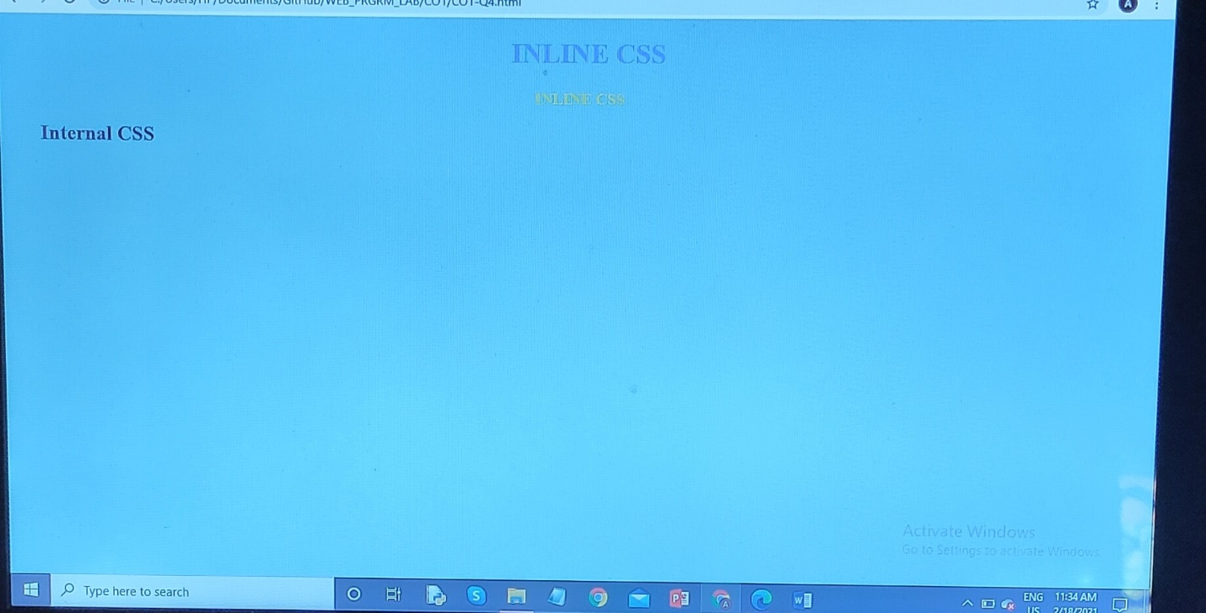

**LABCYCLE 1 QUESTION 5**

**AIM:**  To demonstrate a registration form using HTML

**PROGRAM CODE:**

|  |  |
| --- | --- |
| CO1-Q5.html | <html>  <title>Registration Form</title>  <head>  <style>  body {  font-family: Arial, Helvetica, sans-serif,;  background-color:yellow;    }  table{  color:red;  }    </style>  </head>  <body>  <center>  <font color ="blue">  <u>REGISTRATION FORM</U>  </font>  </center>  <table>  <form>  <tr><td>Name Of Student:</td>  <td><input type="text" name="name"></td>  </tr><br>  <tr><td>Mother's Name:</td>  <td><input type="text" name="name"></td>  </tr><br>  <tr><td>Father's Name:</td>  <td><input type="text" name="name"></td>  </tr><br>  <tr>  <td>Address:</td>  <td><textarea size="20"></textarea></td>  </tr><br>  <tr>  <td>Category:</td>  <td><input type="radio" name="rad" value="male">Male</td>  <td><input type="radio" name="rad" value ="female">Female</td>  </tr><br>  <tr><td>Course:</td>  <td><select><option>B.COM</option>  <option>B.A</option>  <option>B.SC</option>  <option>B.C.A</option>  <option>M.C.A</option>  </select>  </td></tr><br>  <tr><td>Qualifications:</td>  <td><input type ="checkbox" name="qua" value="sslc">S.S.L.C</td>  <td><input type ="checkbox" name="qua" value="plustwo">PLUS TWO</td>  <td><input type ="checkbox" name="qua"value="degree">BCA</td></tr><br>  <tr><td ><input type ="submit"value="Submit"></td></tr><br>  <tr><td align=right><input type ="reset" value="Reset"></td></tr><br>  </form>  </table>  </body>  </html> |

**RESULT**:

